**ADAMA SCIENCE AND TECHNOLOGY UNIVERSITY**

**Computer Science and Engineering Department**

**Section 6**

**Group members ID**

1. **Esrael Dawit UGR/17063/11**
2. **Mekdes Tibebu UGR/17354/11**
3. **Miracle Endelibu UGR/17413/11**
4. **Ofgeha Gelana UGR/17549/11**
5. **Ruth Retta UGR/17589/11**

**Submitted to:**

**Mr. Endale**

**April 8, 2020 G.C.**

**Acknowledgment**

**We have taken efforts in this project. However, it would not have been possible without our oneness.**

**First of all, we would like to thank Mr. Endale, who gave us encouragement to work on this project and gave us feedback (still giving too). He also prepared us to have the capability to handle the project we have proposed.**

**Secondly we would like to thank friends and seniors who were appreciating our idea and giving encouragement. And also we want to thank our campus for providing us such platform to access information on internet.**

**Lastly let our thanks and appreciation goes to all of those who have willingly supporting and helping us out with their abilities.**

**Acronym**

**DRIMS -> Dealer Reduction In Marketing Systems**

**DB -> Database**

**SW -> SOFTWARE**

**Abstract**

**Dealer Reduction in marketing system (DRIMS) is a project concerned with Satisfaction of an end user by supplying timely and accurate information related to goods and services that a legal company or seller provides. This project paper contains detailed information on four major courses namely data gathering, system analysis, system design and implementation.**

**The data gathering part gives an emphasis on what the current situation is like and lists some background projects to compare whereas the system design part states feasibility usability and related concepts. The system analysis part deals with analyzing the system and implementation to some extent is available.**

**Contents**

**Acknowledgment........................................................................................................2 Acronym......................................................................................................................3 Abstract.......................................................................................................................4 List of figures............................................................................................................. 7**

**List of tables............................................................................................................... 9**

**Chapter one…….......................................................................................................10**

**1.1.Introduction.........................................................................................................10 1.2. Background of the organization.......................................................................10**

**1.2.1. Mission of the organization ...........................................................................10**

**1.2.2. Vision of the organization..............................................................................10**

**1.3. Background of the project................................................................................10**

**1.4. Task and schedule ............................................................................................11**

**1.5. Statement of the problem ..............................................................................11**

**1.6. Purpose of the project......................................................................................11**

**1.7. Team composition ....................................................................................12**

**1.8. Objective of the project .................................................................................12**

**1.8.1. General objective........................................................................................12**

**1.8.2. Specific objective ........................................................................................12**

**1.9. Feasibility study ..................................................................................................13**

**1.9.1. Technical feasibility....................................................................................13**

**1.9.2. Operational feasibility....................................................................................13**

**1.9.3. Economic feasibility ...................................................................................13**

**1.10. Scope and limitation..................................................................................14**

**1.10.1. Scope of the study ...................................................................................14**

**1.10.2. Limitation of the project...........................................................................14**

**1.11. Significance of the project...........................................................................14 1.12. Beneficiaries of the project........................................................................14**

**1.13. Methodology .................................................................................................14**

**1.14. Development tools.......................................................................................15**

**1.15. Test plan...........................................................................................................16**

**1.15.1. Unit testing......................................................................................................16**

**1.15.2.Integration testing...........................................................................................16**

**1.15.3. System testing..........................................................................................16**

**1.15.4. Acceptance Testing ....................................................................................16**

**1.16. Project Execution Phase...............................................................................17**

**1.17. Required resources with cost........................................................................17**

**Chapter 2...................................................................................................................19**

**2. Description of existing system.............................................................................19**

**2.1. Major function of existing system...................................................................19**

**2.2. Users of current system ...................................................................................19**

**2.3. Drawback of current system ..........................................................................19**

**2.4. Business rule.......................................................................................................20**

**Chapter 3.................................................................................................................21**

**3. Proposed System...............................................................................................21**

**3.1. Overview........................................................................................................21**

**3.2. Functional requirement...............................................................................21**

**3.3. Non-functional requirement..........................................................................21**

**3.4. System model...................................................................................................23**

**3.4.1. Scenario........................................................................................................23**

**3.4.2. Use case model ...........................................................................................27**

**3.5. Object model....................................................................................................31**

**3.5.1. Data dictionary...........................................................................................31**

**3.5.2. Class diagram .............................................................................................32**

**3.6. Dynamic model..............................................................................................33**

**3.6.1. Sequence diagram.......................................................................................33**

**3.6.2. Activity diagram .........................................................................................40**

**3.6.3 State chart diagram....................................................................................47**

**Chapter 4...................................................................................................................52**

**4. System design ......................................................................................................52**

**4.1. Overview of system design ..............................................................................52 4.1.1. Purpose of the system design..........................................................................52 4.1.2 Design goal.......................................................................................................52 4.2. Proposed system architecture ........................................................................54 4.2.1. System process...............................................................................................55 4.2.2. Subsystem decomposition................................................................................56 4.2.3. Hardware/ software mapping.........................................................................58 4.2.4. Persistent data management...................................................................59 4.2.5. Component diagram ...............................................................................61 4.2.6. Database design...............................................................................................63 4.2.7. Access control ...............................................................................................64 4.2.8. User interface design .......................................................................................66 Reference.....................................................................................................................67**

**List of figures**

**Figure 1 use case diagram................. ................. ................. ................. ............31**

**Figure 2 class diagram................. ................. ................. ................. .................33**

**Figure 3 sequence diagram for registering user................. ................. ...........34**

**Figure 4 sequence diagram for see and access product................. .................35**

**Figure 5 sequence diagram for posting/updating/deleting product................36**

**Figure 6 sequence diagram for posting/updating/deleting transportation.....37**

**Figure 7 sequence diagram for accessing system by using mobile phone.......38**

**Figure 8 sequence diagram for registering branch administrator.................39**

**Figure 9 sequence diagram for commenting and complaining................. ......40**

**Figure 10 activity diagram for registering user................. ..............................41**

**Figure 11 activity diagram for see and access product................. ...................42**

**Figure 12 activity diagram for posting/updating/deleting product.................43**

**Figure 13 activity diagram for posting/updating/deleting transportation......44**

**Figure 14 activity diagram for accessing system by using mobile phone.......45**

**Figure 15 activity diagram for registering branch administrator..................46**

**Figure 16 activity diagram for commenting and complaining........................47**

**Figure 17 state chart diagram for registering user...........................................48**

**Figure 18 state chart diagram for see and access product...............................48**

**Figure 19 state chart diagram for posting/updating/deleting product............49**

**Figure 20 state chart diagram for posting/updating/deleting transportation..49**

**Figure 21 state chart diagram for accessing system by using mobile phone...50**

**Figure 22 state chart diagram for registering branch administrator..............51**

**Figure 23 state chart diagram for commenting and complaining....................51**

**Figure 24 system architecture..............................................................................54**

**Figure 25 system activity design..........................................................................55**

**Figure 26 overall DRIMS.....................................................................................55**

**Figure 27 system process......................................................................................56**

**Figure 28 subsystem decomposition ..................................................................57**

**Figure 29 hardware/software mapping...............................................................59**

**Figure 30 class to relational database mapping................................................59**

**Figure 31 product mapping................................................................................60**

**Figure 32 consumer mapping.............................................................................60**

**Figure 33 producer mapping..............................................................................60**

**Figure 34 administrator mapping......................................................................61**

**Figure 35 transportation mapping ....................................................................61**

**Figure 36 save comment mapping......................................................................61**

**Figure 37 component diagram............................................................................62**

**Figure 38 deployment diagram...........................................................................63**

**Figure 39 database design...................................................................................64**

**Figure 40 user interface.......................................................................................66**

**List of tables**

**Table 1 task and schedule....................................................................................... 12**

**Table 2 team composition....................................................................................... 13**

**Table 3 software used............................................................................................. 17**

**Table 4 project execution phase............................................................................ 18**

**Table 5 required resource with cost..................................................................... 18**

**Table 6 data dictionary.......................................................................................... 32**

**Table 7 subsystem description.............................................................................. 58**

**Table 8 access control.............................................................................................65**

**Chapter one**

* 1. **Introduction**

**In this era of information having a timely and accurate information is all what we need to make life easier. As we get access to a quality information our actions become influenced by it. Our system overall is dedicated on providing this information by allowing users to describe themselves as legal providers put detailed information about their products and location on the database. Users then select the product/ products or service/ services they want to have and immediately get access to the providers address. If users want to have a transport access they can select a transport provider which is available on the DRIMS system. Users can also give comments and complement products which in turn increases the reliability of the service provider but mainly helps the end user by giving a more suitable choice. This document is a compilation of all the process and description of ways and methods used to solve the problem.**

* 1. **Background of the organization**

**DRIMS organization is a composed of 5 undergraduate students who are very eager to solve the problem in the marketing system learning at Adama science and Technology University.**

* + 1. **Mission of the organization**

**Our mission is being a bridge that connects an end user directly to supplier of products, via an internet connection when available or a USSD code, to reduce the chain of dealers on the market system and satisfy end users.**

* + 1. **Vision of the organization  
       To provide the most satisfactory, helpful, and lovable software on the market which could compete and exceed all other software related to marketing system in eastern Africa.**

**1.3. Background of the project**

**Previous projects which are on use are accessed by smart phones, the payment is completed via the systems and users can have transportation services. The systems we saw was concerned with connecting on the basis of selling or buying. There is a lack of user participation because of accessibility and end users satisfaction. Our system is designed to encompass a vast amount of society starting from the farmer to Big companies and enterprises sharing information and earning each-others trust. Providers themselves put a price tag on the product or service they give making it even easier to mace economical decision for the end user. Our system is all about provision of information.**

**1.4. Task and schedule**

|  |  |  |  |  |
| --- | --- | --- | --- | --- |
| Phase | Months |  |  |  |
|  | **Mar 12**  **-**  **Mar 25** | **Mar 26**  **-**  **Mar 30** | **Apr 1**  **-**  **Apr 20** | **Apr21**  **-**  **Apr 26** |
| Requirement gathering and analysis |  |  |  |  |
| Design |  |  |  |  |
| Implementation |  |  |  |  |
| Testing |  |  |  |  |

**Table 1 Task and schedule**

**1.5. Statement of the problem**

**We were motivated to do this project by the following problems which are in need of a solution. The problems that caught our mind are:-**

* **Lack of end users satisfaction**
* **Lack of primary producers profitability**
* **Lack of true price supply**
* **Dealers benefit for doing not so much**

**1.6. Purpose of the project**

**The main purpose of the project is to reduce problems existing systems couldn’t overcome by applying simple and usable mechanisms.**

**1.7. Team composition**

|  |  |  |  |
| --- | --- | --- | --- |
| **Title** | **DRIMS** |  |  |
|  | **Name** | **Email** | **Roll** |
|  | **Esrael Dawit** | **esraeldawit0@gmail.com** | **Requirement gathering, implementation,**  **Diagram design,** |
| **Team composition** | **Mekdes Tibebu** | [**tibebumekdes630@gmail.com**](mailto:tibebumekdes630@gmail.com) | **Requirement gathering, diagrams, implementation** |
|  | **Miracle Endelibu** | [**miracilious731@gmail.com**](mailto:miracilious731@gmail.com) | **Requirement elicitation,**  **secretary,**  **diagram,**  **implementation** |
|  | **Ofgeha Gelana** | [**ofgehagelana2019@gmail.com**](mailto:ofgehagelana2019@gmail.com) | **Diagram and software design, implementation**  **Requirement gathering,** |
|  | **Ruth Retta** | [**ruthretta2000@gmail.com**](mailto:ruthretta2000@gmail.com) | **Coordinator, diagram and software design, implementation** |
| **Advisor** | **Ins**  **Endale.Aragu** |  |  |

**Table 2 Team composition**

**1.8. Objective of the project**

**1.8.1. General objective**

**The general objective of this project is to develop web based application for buyers, sellers and transporters and to connect them online.**

**1.8.2. Specific objective**

**Achieving the main objective could not be possible without achieving these specific objectives.**

* **Studying about problem of the existing system of the marketing SW**
* **Gathering required information for proposed system**
* **Analyzing the gathered information.**
* **Considering applicability of proposed system for the market**
* **Designing the proposed system**
* **Implementing the system**
* **Testing the system**

**1.9. Feasibility study**

**Feasibility is essential to decide whether to continue or stop doing the given project as it tells us the value it adds to the world. In other words it describes what we might lose if the system is not constructed. It includes the following parts**

**1.9.1. Technical feasibility**

**Technical feasibility is choosing suitable technology and resources.**

**For the purpose of quick development we are going to use python web framework Django, MySQL and for providing organized and managed system development process we are using Trello.**

**So, DRIMS is technically feasible as it uses recent tools to develop the needed product.**

**1.9.2. Operational feasibility**

**Operational feasibility is defining how much of the problem the system solves well and its usability (easy to use by end users). The one which is accessible for smart phone can access all DRIMS service by our website. And for those who can’t have the privilege of accessing the internet there is message and call service and can access all the services of DRIMS.**

**So, DRIMS is operational feasible.**

**1.9.3. Economic feasibility**

* **Financial benefits**

**We tried to calculate the price that is needed to deploy our system. at least we need a big server and database the average monthly payment for the server = 1,000,000 birr per year this value could be 12,000,000 birr.**

* **Business process benefits**
* **Better decision making**
* **Better service to the market system**
* **High information exchange between the organizations**

**1.10. Scope and limitation**

**1.10.1. Scope of the study**

**The scope of this project is clearly stated below because of what the system is expected to perform. The proposed system DRIMS (Dealers Reduction IN Marketing System) focuses on Reducing Dealers Among Producers (companies, farmers,….) And End Users (anyone) Since Now Times Because Of Involvement of many Dealers in Marketing There Is a big Increase In Price of goods because Every Single Dealer Needs Extra Profit From Any Product After Some Time The Price Of That good increases From its Real Price. Our system doesn’t include payment and transaction management it intends to provide timely, accurate, and reliable information.**

**1.10.2. Limitation of the project**

* **Our system doesn’t conduct any transaction inside.**
* **Shortage of time and compactness of schedules influenced us negatively**
* **Not accessible in paces with no network connection**

**1.11. Significance of the project**

**Some of the significance of this project include:**

* **End user satisfaction**
* **Producer satisfaction**
* **Fast transaction**
* **Reliability of products**
* **Good decision making**

**1.12. Beneficiaries of the project**

**The primary beneficiaries from this project are end users then producers also benefit indirectly. The project managers also benefit from the system.**

**1.13. Methodology**

**Data collection methodology**

**Observation - observing the current problem in the marketing system**

**Data analysis - analyzing some information related to market**

**System analysis and system design methodology**

**In this project the team will use object oriented system development methodology (OOSD). having two phases**

1. **Object Oriented Analysis (OOA)**

**During this phase the team used to model the function of the system (use case modeling), find and identify the business objects, organize the objects and identify the relationship between them and finally model the behavior of the objects.**

1. **Object Oriented Design (OOD)**

**During this phase the team uses enterprise architect software to refine the use case model, and to reflect the implantation environment, model object interactions and behavior that support the use case scenario, and finally update object model to reflect the implementation environment.**

**Deployment/ implementation methodology**

**Implementation is coding of all functions specified by requirement analysis and design. To perform this we will use client server architecture. The server provides service to the client and the client requests service from server. So we will have servers and clients (computers) on the system will be hosted.**

**System development methodology**

**We use agile development modeling because we were asked to develop a system. Agile development model is suitable for our project because:**

* **Time was short**
* **Requirements were not well known**
* **Ambiguous requirements**
* **Easier to make**

**1.14. Development tools**

**Hardware: ➢**

* **Computers**
* **Flash**
* **CD-ROM**

**Software:**

|  |  |  |
| --- | --- | --- |
| **Tools** | **Abbreviation** | **Use** |
| **Django t** | **Django** | **For design** |
| **Enterprise architect** | **EA** | **For designing diagrams** |
| **Trello** | **Trello** | **Project management** |

**Table 3 software used**

**1.15. Test plan**

**Testing is the process of checking for errors by running a certain software. It can be classified as:**

**1.15.1. Unit testing**

**This refers to checking each and every system on its own by running it separately.**

**A. Black box testing**

**In this technique, we will test to see if the function of the system is fully operational or error free. This includes testing the interface of the system rather than the logical structure of the system.**

1. **White box testing**

**We will use this approach to know the internal working style of the system, test that all internal operations are performed according to specifications and all internal components have been exercised and the logical path of the system are correct.**

**1.15.2. Integration testing**

**Concerned with testing architectural design of the system. Approaches of testing are:**

1. **Top –Down integration testing**

**This will perform starting from the top module up to the last or bottom module individually (tests were run as each individual module is integrated).**

1. **Bottom-up integration**

**We will begin with the lowest –level modules which are combined to cluster, or build that perform a specific software sub-function (top-level).**

**1.15.3. System testing**

**After completion of the above testing mechanisms we would be confident enough to let our system be tested by a third party and accept comments.**

**1.15.4. Acceptance Testing**

**This testing is done by the customer to ensure that the delivered product meets the requirements and works as the customer expected. It includes:- •**

* **Alpha- Conducted by users to ensure they accept the system •**
* **Beta- Users use real data, not test data**

**1.16. Project Execution Phase**

|  |  |  |  |
| --- | --- | --- | --- |
| **Roll no** | **Phase** | **Required time** | **Function** |
| **1** | **Data collection and gathering** | **Pen**  **Paper**  **Computer**  **Flash**  **Word** | **Get information about existing system.** |
| **2** | **Requirement elicitation and analysis** | **Pen**  **Paper**  **Computer**  **Flash**  **Word** | **Identify requirements and define the functions of the project(elicitation)**  **Analyze validate and understand the requirement(analysis)** |
| **3** | **Design** | **MSWORD**  **Paper**  **Computer**  **Flash drives**  **SQL server** | **Transform user requirement into implementation suitable form.**  **To identify and understand the class in order to reuse, refine and remove vague classes** |
| **4** | **Coding and implementation** | **Computer**  **Flash**  **Server**  **MySQL**  **Django**  **Trello**  **Git** | **Typing code within the selected programming language in order to implement the function of the project.** |
| **5** | **Testing** | **Computers**  **Mobile**  **Servers** | **Identify faults and errors in the project.** |

**Table 4 Project execution phase**

**1.17. Required resources with cost**

|  |  |  |  |
| --- | --- | --- | --- |
| **Material name** | **No material** | **Price** | **Total price** |
| **Paper** | **50** |  | **50** |
| **Pen** | **5** |  | **50** |
| **Laptop** | **5** |  | **50,000** |
| **Flash 4GB** | **1** |  | **150** |
| **Total cost** |  |  | **50,250** |

**Table 5 required resource with cost**

**Chapter 2**

**2. Description of existing system**

**Currently there exist many different marketing systems in our universe. Especially in our country Ethiopia there are many dealers that are waiting to negotiate with producers and consumers in order to take advantage, which is manually done.**

**There are some digital systems which are concerned on the product that whether they are going to be sold or not. And they perform many different tasks like: payment system, product uploading, ordering, having account, etc.**

**The target of this system is to reduce the dealers in between, satisfying the end consumer of the product in different aspects and giving information for the users.**

**2.1. Major function of existing system**

* **In digital system:**
* **Payment system**
* **Creating accounts**
* **Managing products**
* **Ordering system**
* **In manual system**
* **Communicating with producers**
* **Communicating with consumers**
* **Negotiating about the payment**

**2.2. Users of current system**

* **In digital system**

1. **Companies/administrator**

* **Manage every actions**

1. **Users/consumers**

* **Ordering**
* **Pay for the service provided**
* **In manual system**

1. **Dealers**

* **Negotiating with both consumers and producers**

1. **Producers**

* **Searching for consumers**

1. **Consumers**

* **Searching for producers**

**2.3. Drawback of current system**

**The drawback of the manual system is that:**

* **It is very time consuming**
* **Many dealers are involved in the process**
* **The consumers may not be happy with price**
* **It might not have a transportation system**
* **The product may be low in quality**

**2.4. Business rule**

**1. The administrator has access to make branch administrators**

**2. Branch administrator is restricted on some tasks compared to administrators**

**3. User must register to get access to the system**

**4. Posted products must be validated based on the standards**

**5. Users can be banned if any inappropriate attempt is noticed**

**6. Only the user can update his profile**

**7. Viewers have no access except loading the page, if they are not registered**

**Chapter 3**

**3. Proposed System**

**3.1. Overview**

**The proposed system is designed to reduce the number of dealers on the marketing system. Project Management System in to computerized system and also designed to store the transaction information in the database for the purpose of reducing the problem faced by manual system. The application composes different forms to enter different project detail to the database and retrieve required information of the project from the database.**

**3.2. Functional requirement**

**Functional requirements are requirements that our system is intended to do. The major functional requirements are listed below.**

**1. Manage account (create, update, Restrict, delete and view account as producer, consumer Or Normal User)  
2. Register products and their status.**

**3. Register Branch Admins**

**4. Validate users (Authentication)**

**5. Restrict or Ban Users.  
6. Give and accept Comments.  
7. Register producer (add, delete and update) and Authenticate Users (OTP or Email Verification) is the data entered is valid or Not and then Register  
8. Register consumer (add, delete and update).  
9. Show Current Currency Exchange Rate.**

**10. Show True Price Of goods.**

**11. Notify Users (Email, Voice or Message Notification).**

**12. Register Transportation provider.**

**13. Connect producers with consumers.**

**3.3. Non-functional requirement**

**Non-functional requirements are requirement, which has no essential for the system, but it can support and give more quality for the system.**

**A. Users interface requirement**

* **User interface should be menu driven and attractive.**
* **The interface should be user friendly.**
* **The system should support error-handling mechanism that display graphic approach and the system guide the user what will be the next action.**

**B. Authentication Requirement.**

* **The system support user name and password to authentic.**
* **The system has different privilege to protect intruding.**

**C. Robustness (Error handling requirement):**

* **The system have error handling mechanisms that is, as errors occur it will not stop functioning rather provide error manages and back to the previous page to give chance to reenter data and process the task by beyond the error.**

**D. Well documented:**

* **the document of this project is processed in well manner**

**E. Resources:**

* **The system is compatible with specified hardware and software environment**

**F. Usability**

**The system is user friendly. The new system provides web application user interfaces that are compatible with any browsers.**

* **The system shall provide the easy access**
* **The system is easy to deal with.**
* **The system should is easy to understand.**
* **Unauthorized person should not use the system; rather just view the main page.**
* **No one can change the password without login to the system**

**G. Hardware consideration:**

**The following sub-sections discuss the various aspect of hardware requirement.**

* **Processing power: 64 bit operating system and Intel(R) core (TM)i3-237M CPU @1.50GZ.**
* **Memory and secondary storage: more than 4GB, 500GB hard disk and swap space (if the RAM is insufficient).**
* **Peripherals: includes CD ROM device, network device, etc.**

**H. Software consideration:**

* **Platform: our system supports any operating system and all browsers. I. Performance requirement the system performs its task within a user acceptable time and space. This includes the following:-**
* **Response time: - depending on the strength of available network the system should be response in short period of time.**
* **Storage space:-to do work efficiently the processor to be more than 2GB RAM,**

**I. Reliability:**

* **The system should be reliable. Appropriate error messages will be provided to users whenever incorrect information is inserted and handle the occurrence of that error.**

**3.4. System model**

**System model is an abstraction of a system that focuses on interesting aspects and ignores irrelevant details. The DRIMS system basically contains three types of system models namely:**

**1. Functional model (scenario, use case model)**

**2. Object model (class diagram)**

**3. Dynamic model (sequence, activity and state chart diagrams).**

**3.4.1. Scenario**

**Scenario is real-life example of how the system can be used. It should include scenario name, flow of event, what can go wrong and how this is handled. Based on this the following scenarios for our project are listed below.**

**1. Registering users (buyer, seller or transport provider)**

**Initial assumption:**

**Let assume that our customers use android phone and there is access for using the system.**

**Normal condition:**

**First search the system’s web-page with its link then the web-page displayed with different kinds of button. From this button he selects registration button. The system suggests different kind of registration buttons means buyers registration, sellers registration and transportation registration. Then, the system displays registration forms. Then, he/she will fill the form. The system checks the forms for validation and generate password for them that used for login use case.**

**What can go wrong?**

**If the forms not filled appropriately the system display the error encountered when filling forms and request them to reenter. Then they can correct the errors.**

**2. See products and get access to it**

**Initial assumption:**

**A consumer initially has a buyer account and wants to consume/buy a product**

**Normal:**

**The user must load the web page then he must login by using his buyer user name and password. After logged in to his account the system will display every available product on his page. If the buyer wants to see the details of the product before selecting it, he can click the “Detail” button and can have full information of the product. After checking the products and decide what to buy he can click on the “Select” button. If the consumer want to know the price he can he just ne ed to click the “Calculate” button on the product icon after inserting the amount he wants the system will calculate the total amount of money needed to buy that product. If the buyer can afford the price mentioned he just has to click the “agree” button. And the system will automatically send notification to the producer of the product by different means (messaging, email). And if the system will display the address of the seller to the buyer. The system will offer the user if he needs transportation access, if the user needs the access he can see available transportation systems and allow the user to select. After the user selects the system will display the information he needs to contact with the transportation provider.**

**3. Posting/ updating/ deleting products**

**Initial assumption:**

**The producer is already registered and wants to post product/s or update the available one.**

**Normal:**

**The producer will load the page and login to his seller account. If his username and password are valid the system will allow him to load his account.**

**If he wants to add new product/s he have to click on “post product” button and browse the product photo/video and detail information from his working device or drag and drop it there.**

**If he wants to update currently available product/s he can go to the right bottom of the product icon and click on “edit” and then he can edit the photo/video or the detail information.**

**If he wants to delete a product from his page because of different reasons he just have to click on “delete” button which is appearing on the left bottom of the product icon.**

**After these actions of the seller the system will notify the updated information to price checker and quality checker and if they give confirmation to the products the system automatically will update the buyer’s and visitor’s(main page of the web) page.**

**What can go wrong?**

**If the price/quality checker does not confirm the products the system will give notification to the seller that the product is not a right product/the price is not fair. If the seller gives correction to the product he posted he can go on but if he do the same thing again and again he will get warning or he may be banned at all.**

**4.Adding/ updating/ deleting transportation system**

**Initial assumption:**

**The transport provider may be a single person or a company in which many cars and people are included. For now we use the general term ‘transport provider’ to include both of them. The transport provider is registered on the system and already has an account.**

**Normal:**

**The transport provider logs on to the system.**

**If he wants to update the information of available transport system it can update the information of all of the working cars instantaneously.**

**If he wants to add newly available transport system it can add a new information by clicking the “add” button.**

**If it wants to remove the transport system he can delete the information.**

**What could go wrong?**

**5. Accessing the system by using any mobile phone**

**Initial assumption:**

**The user has an account and a smart phone and he has an access to the net.**

**Normal the user opens browser and logs in to the system then selects whatever product he is needing.**

**What can go wrong?**

**Someone wants To buy A product From producer But He doesn’t Know How To use or Read so He can use Our Mobile Calling System message or Voice Call instructions and he after All his Requirements are Chosen Then He Selects And Confirms His Choice Then ,He Will Get Phone Number or Email Address Of Seller And Transport Access.**

**6. Registering branch admin**

**Initial assumption:**

**The admin will choose whom to employee.**

**Normal:**

**If the admin wants to select a branch admin from the recent users (buyer, seller, and transport provider) he can go to their profiles and give permission in order to make them a branch admin with restrictions.**

**If the admin wants to employ new branch admin by making a registration form for the appliers he must first release the form to be filled then after applicants have registered and filled the form properly until the due date, he will select one/some of them. Then the system will automatically send a notification which includes key features to access the system (by SMS/email) to the applicants.**

**7. Commenting and complaining**

**Initial assumption:**

**The producer, consumer and transportation provider registered and already validated and logged in with proper user name and password. The visitor is visiting the web. And they get the services of DRIMS or just visiting the site.**

**Normal:**

**If buyer, seller, transporter or visitor wants to give comment, click the comment button, then texting box will display on page. The commenting user will write the comment and post it by clicking comment button. If they have complain they can complain by clicking on the complain button and write it down then click complain button. And the complaint is visible only for the admins. Then the admins must notified as soon as complaints post complains. And admins give response by clicking on response button on the system then response box will be displayed. Admins add response and click on send response button. That will send back to customer.**

**What can go wrong?**

**The customer’s commenting or complaining box is empty. The system must reply with empty comment or complain.**

**3.4.2. Use case model**

**Actors**

**Actors of our projects are:**

* **Buyers**
* **Sellers**
* **Transportation**
* **Administrator**
* **Branch administrator**
* **Phone and computer**
* **Visitor**
* **True price suppliers**
* **Printers**

**Primary actors**

**Primary actors of our project are:**

* **Buyers**
* **Sellers**
* **Transporters**
* **Visitors**
* **Administrator**

**Secondary actors**

**Secondary actors of our projects are:**

* **Administrator**
* **Branch Administrator**
* **Printers**
* **Phone**
* **Price checker**
* **Quality checker**

**Use Case identification:**

**Our system includes the following use cases:-**

* **login**
* **register product**
* **register buyers**
* **register sellers**
* **register transport**
* **display error**
* **authenticate password**
* **accepting notification**
* **register branch admin**
* **select items**
* **display item info**
* **display registered successfully**
* **verify register**
* **update products**
* **update transportations**
* **commenting**

**View detail: used to view all information included under the system, such as:**

* **view product**
* **view price**
* **view comment**
* **view transportation**

**Update details: used to update the required information in the system such as:**

* **update products**
* **update transportations**
* **update price**

**Delete details: Used to delete all irrelevant information in the system, such as**

* **delete products**

**Actors’ identifications:**

* 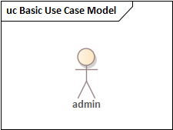**Register branch admin**
* **Login to the system**
* **View information**
* **Manage account**
* **Accepting comment**
* **Log out**
* **Give comment**
* **Verify register**
* **Change password**
* **Delete customers**

* **Registration**
* 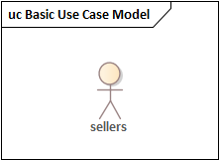**Login**
* **Viewing information**
* **Accepting notification**
* **Logout**
* **Update products**
* **Selects transporters**

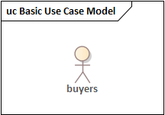

* **registration**
* **Login**
* **Logout**
* **Commenting**
* **Select items**
* **View information**
* **Select transporters**
* **Seller address view**
* 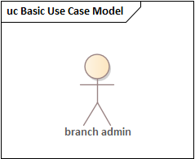**Login**
* **Manage account**
* **Commenting**
* **View information**
* **Logout**
* **Change password**
* **Delete registration**
* **Delete products**
* **View information**
* 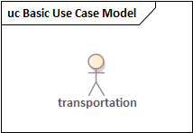**Registration**
* **login**
* **Update transportation status**
* **Commenting**
* **Accepting notification**
* **Logout**
* **Select items**
* **View information**

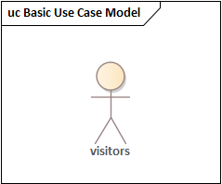

* **view information**

**Use Case Diagram of the project**

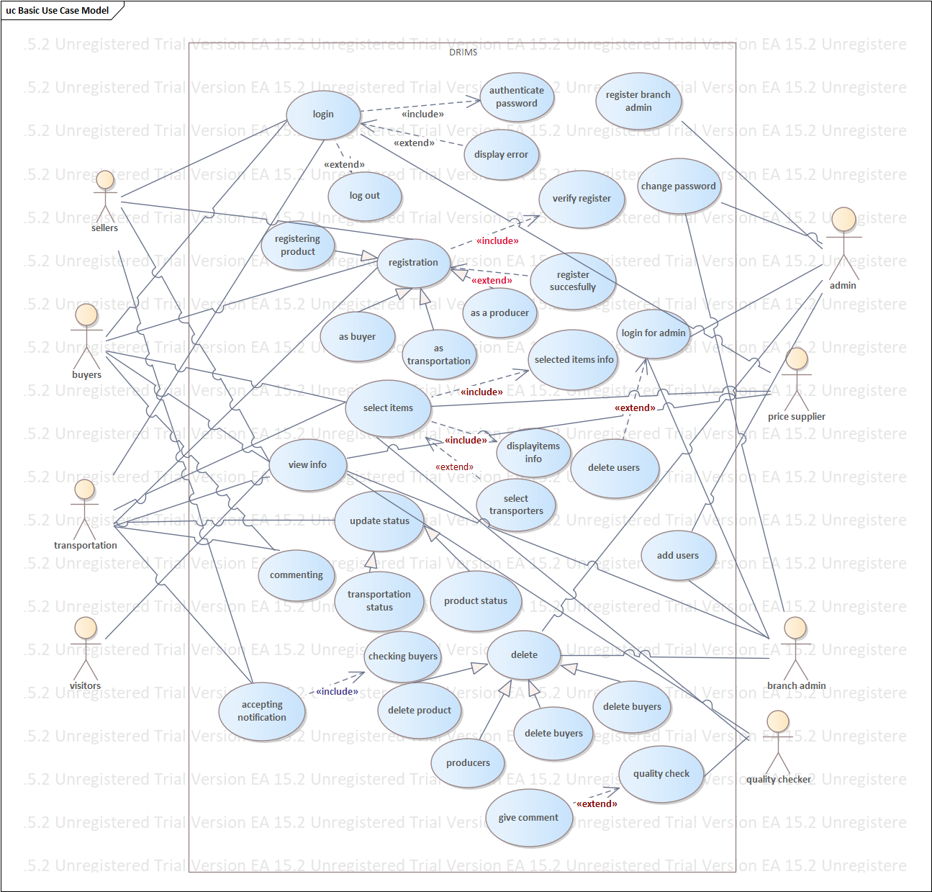

**Figure 1 use case diagram**

**3.5. Object model**

**3.5.1. Data dictionary**

|  |  |  |  |
| --- | --- | --- | --- |
| **Classes** | **Attributes** | **Operations** | **Descriptions** |
| **Product** | **Product ID, product name qualification,**  **Specification.** | **Add product()** | **To add products and update them** |
| **Transport** | **Transport provider, transport type, transport fee.** | **Add transport()** | **To add transportation services** |
| **Schedule** | **Sid, delivery date, delivery time, order time** | **Set schedule()**  **View schedule()**  **Update schedule()** | **To use schedule properly** |
| **Account** | **User id, user full name, status, location.** | **Log in()**  **Create account()**  **Delete account()** | **To access the given products** |

**Table 6 data dictionary**

**3.5.2. Class diagram**

**We use class diagram to describe the structure of a system by showing the system's classes, their attributes, operations (or methods), and the relationships among objects. For designing of Class diagram, we have used Unified Modeling Language (UML). This diagram is the main building block of our object-oriented modeling. The team applies it for both general conceptual modeling of the systematic of the application, and for detailed modeling translating the models into programming code. The classes in a class diagram represent both the main objects, interactions in the application and the classes to be programmed. In the system, Classes are abstractions that specify the attributes and behavior of a set of objects and Objects are entities that encapsulate state and behavior. Each object has an identity: It can be referred individually and is distinguishable from other objects. In mapping the diagram, we have used the following criteria:**

**One –to- One relationship:-here when both involved entities exchange primary keys where the new exchanged primary keys become the new foreign keys of the tables.**

**One –to- many relationships:-here the primary key on the many side has been mapped to the one side.**

**Many –to- many relationships:-here the primary key on the many side has been mapped to the many side. The association of classes is described with diagrams as follows:**

**Class diagram**

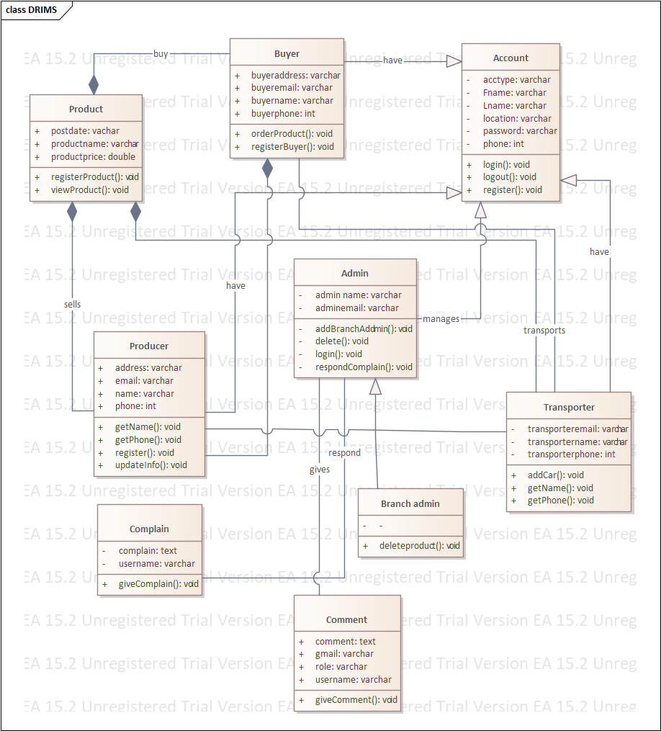

**Figure 2 class diagram**

**3.6. Dynamic model**

**3.6.1. Sequence diagram**

**As the name indicates, the system used sequence diagram to show sequence of activities or how processes operate with one another and in what order. It is a construct of a Message Sequence Chart. It shows object interactions arranged in time sequence. It depicts the objects and classes involved in the scenario and the sequence of messages exchanged between the objects needed to carry out the functionality of the scenario. Sequence diagrams are typically associated with use case realizations in the Logical View of the system under development. With this diagram we show, as parallel vertical lines (lifelines), different processes or objects that live simultaneously, and, as horizontal arrows, the messages exchanged between them, in the order in which they occur. This allows the specification of simple runtime scenarios in graphical manner. We have listed the sequence diagram as follows:**

**1. Registering users (buyers, seller, transport)**

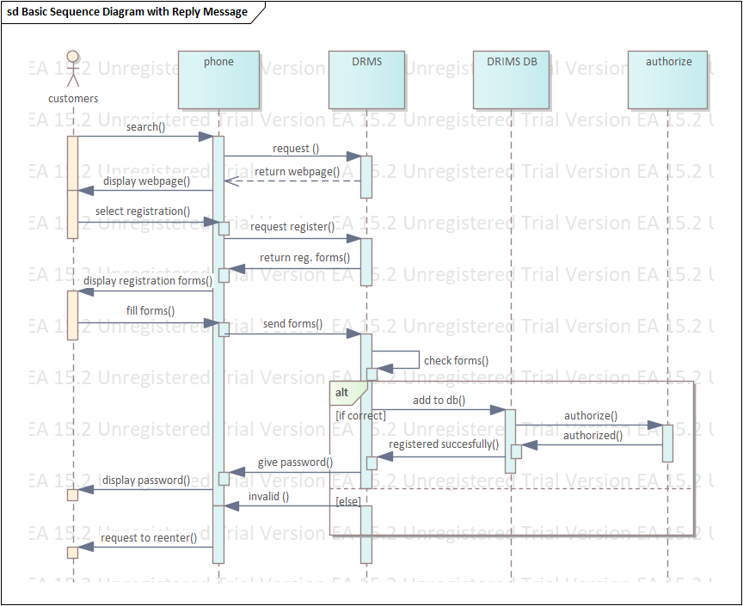

**Figure 3 sequence diagram for registration of user**

**2. See and access product**

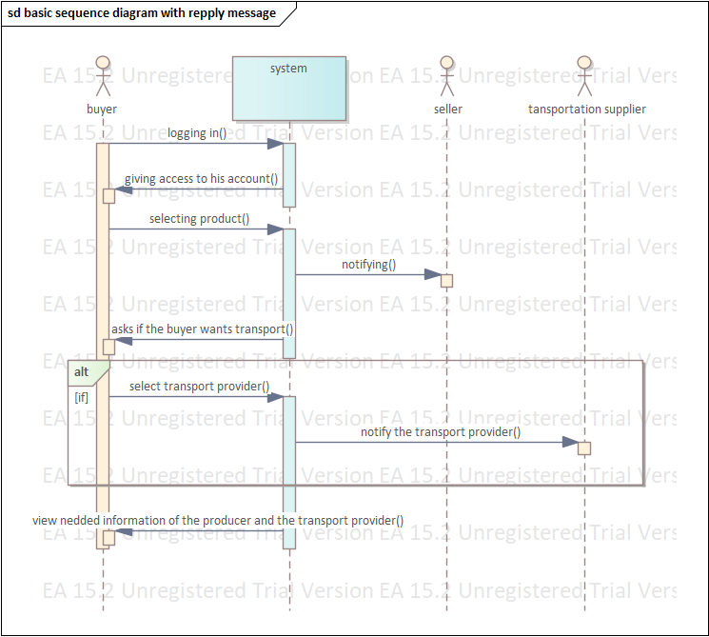

**Figure 4 sequence diagram for see and access product**

**3.Posting/ Updating/ Deleting product**

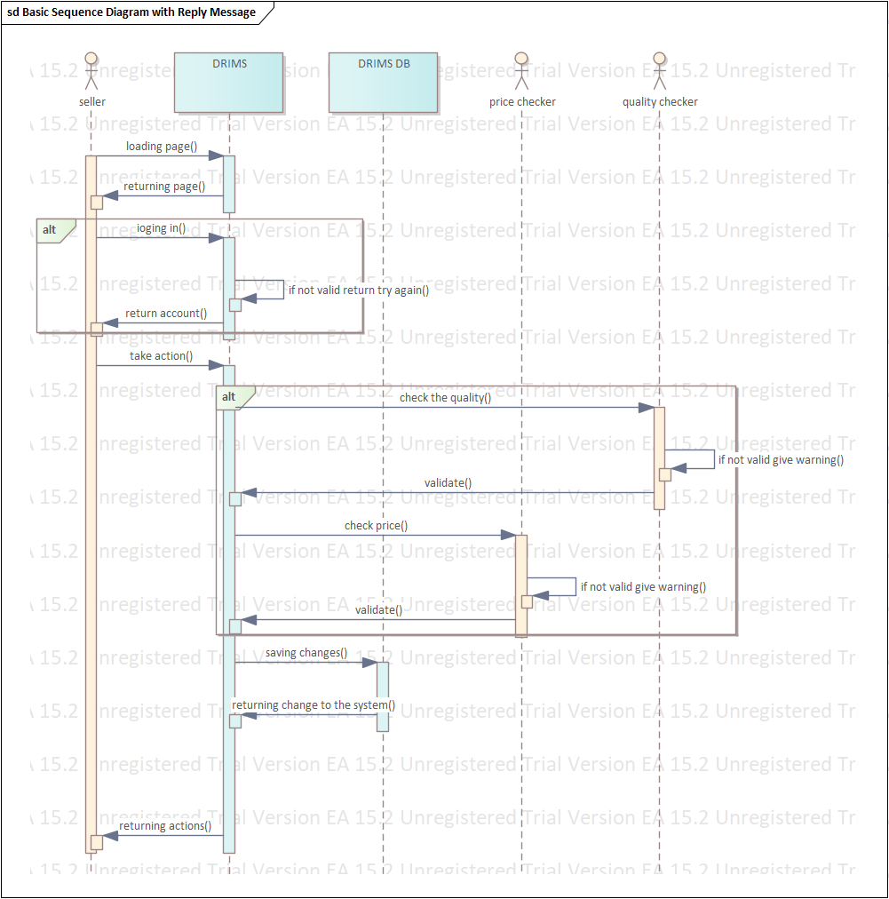

**Figure 5 sequence diagram for Posting/ Updating/ Deleting product**

**4.Adding/ Updating/ Deleting transportation**

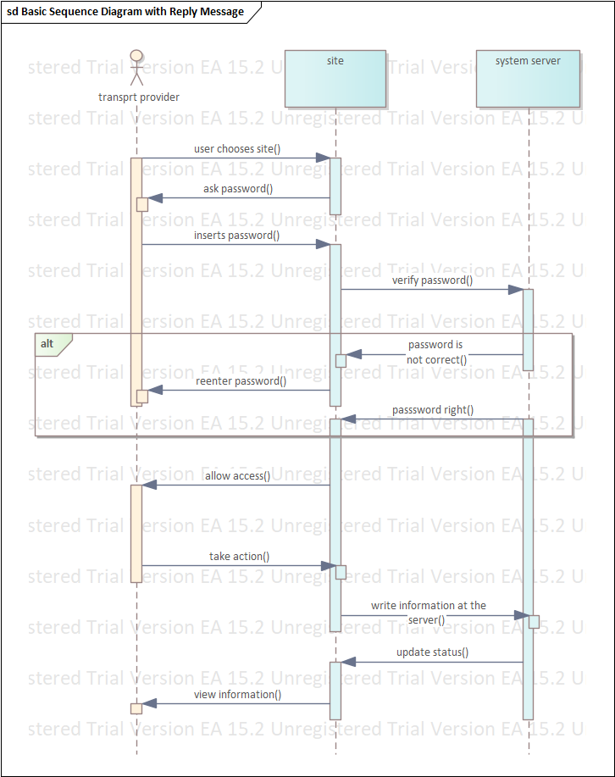

**Figure 6 sequence diagram for posting/updating/deleting transportation**

**5.Accessing system by using mobile phone**

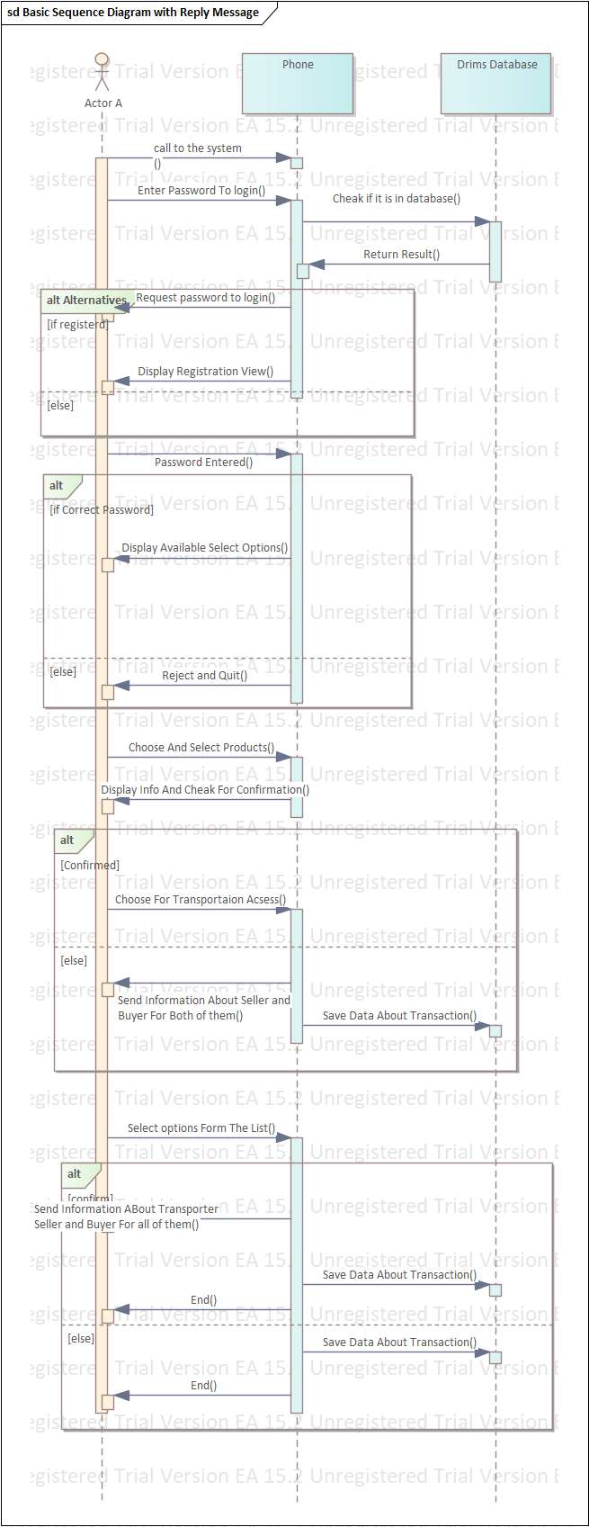

**Figure 7 sequence diagram for accessing system by using mobile phone**

**6.Registering branch admin**

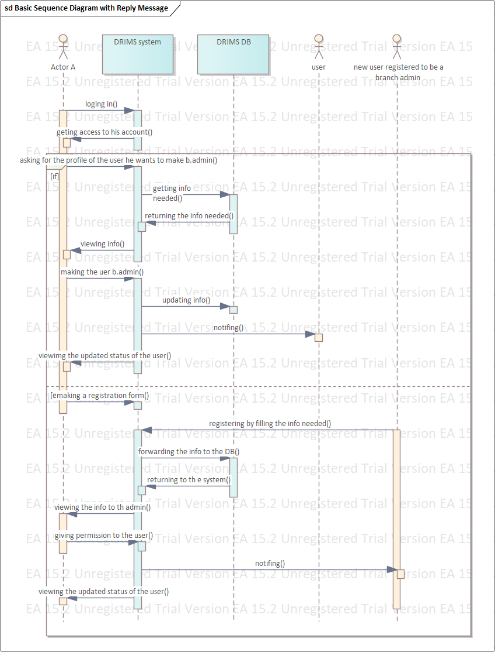

**Figure 8 sequence diagram for registering branch administrator**

**7.Commenting and complaining**

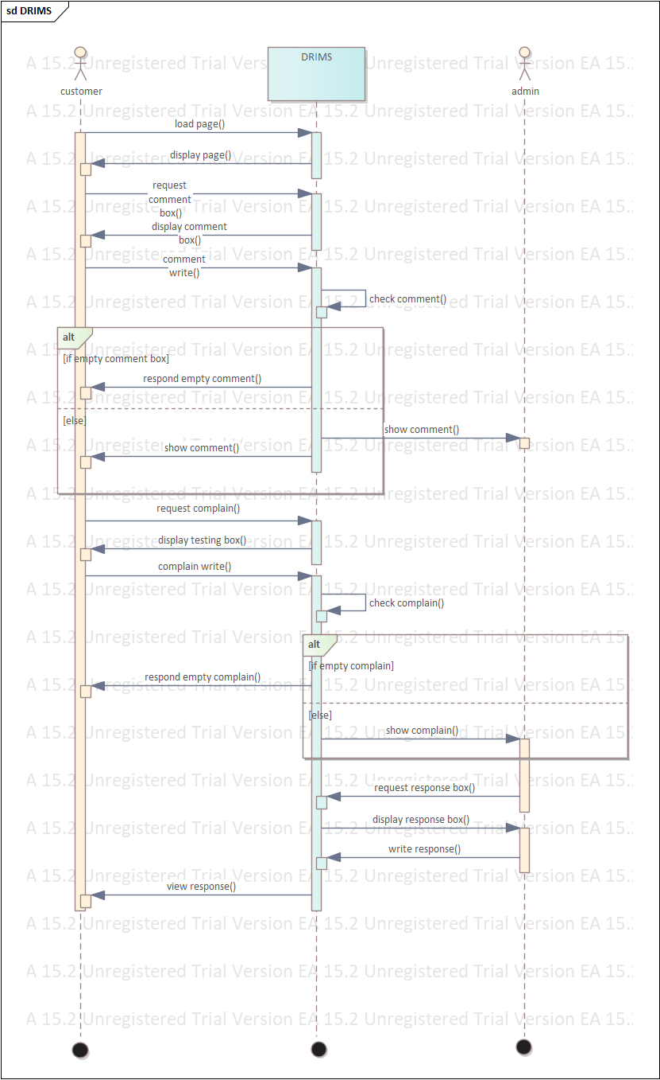

**Figure 9 sequence diagram for commenting and complaining**

**3.6.2. Activity diagram**

**An activity diagram is used to understand the flow of work that an object or component performs. It can also be used to visualize the interaction between different use cases. One of the strengths of activity diagrams is the representation of concurrent activities. Some of the activity diagrams of our system are listed below.**

**1. Registering users (buyers, sellers, transport)**

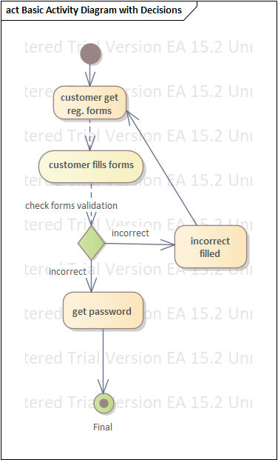

**Figure 10 activity diagram for registering user**

**2. See and access product**

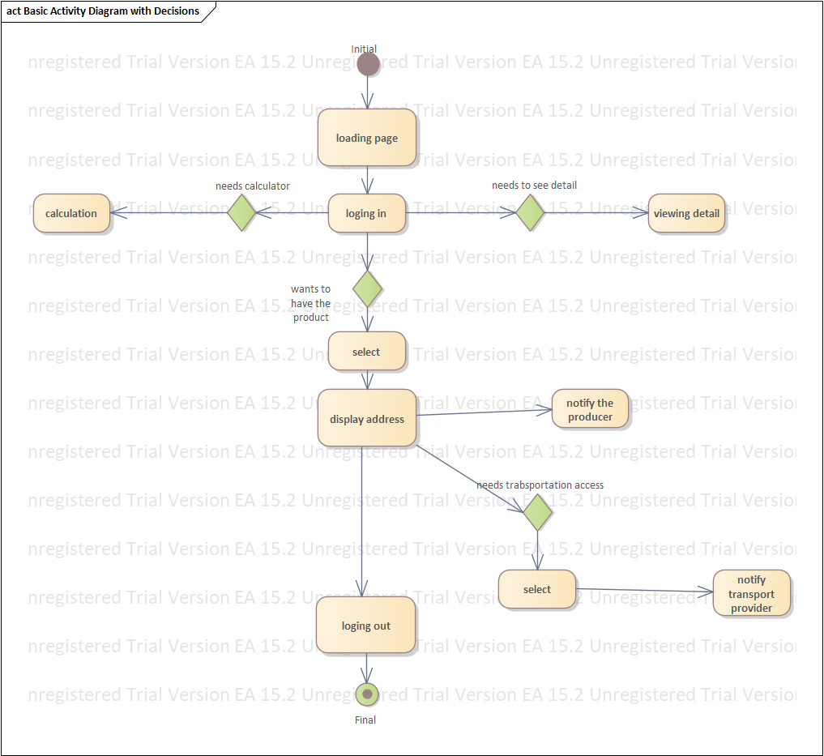

**Figure 11 activity diagram for see and access product**

**3. Posting, updating, deleting products**

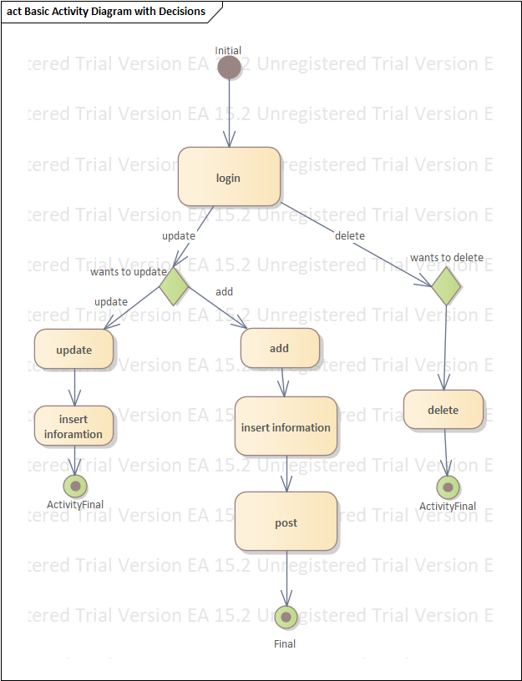

**Figure 12 activity diagram for posting/updating/deleting product**

**4. Adding/ updating/ deleting transportation**

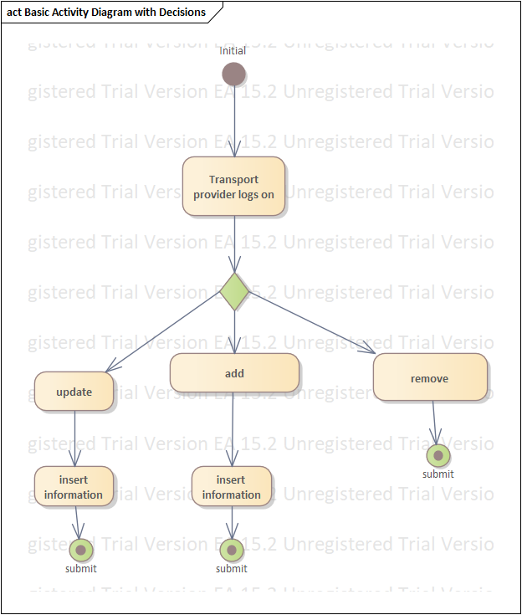

**Figure 13 activity diagram for posting/updating/deleting transportation**

**5. Accessing system by mobile phone**

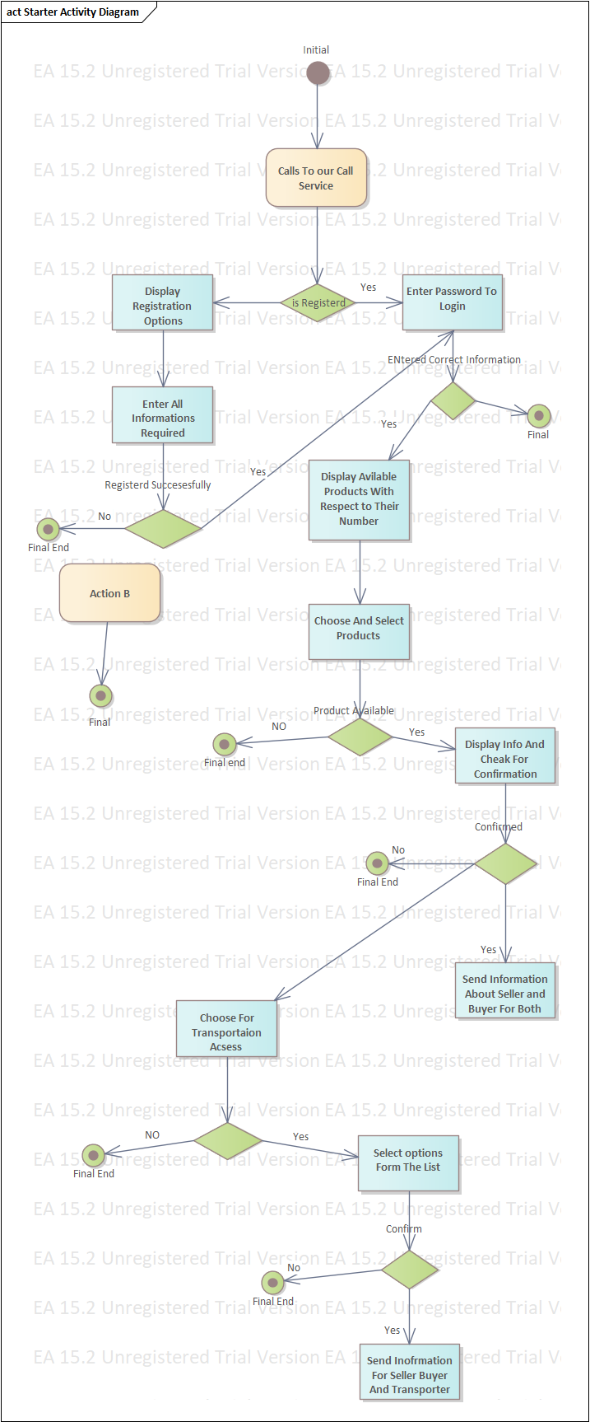

**Figure 14 activity diagram for accessing system by using mobile phone**

**6. Registering branch admin**

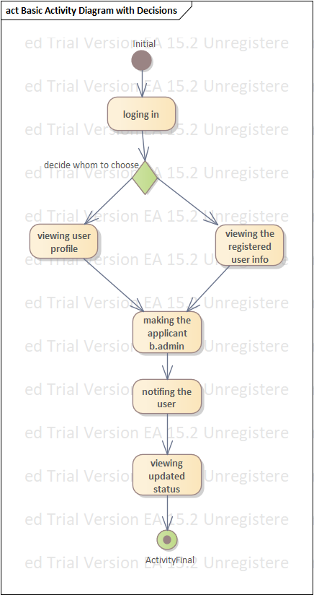

**Figure 15 activity diagram for registering branch administrator**

**7. commenting and complaining**

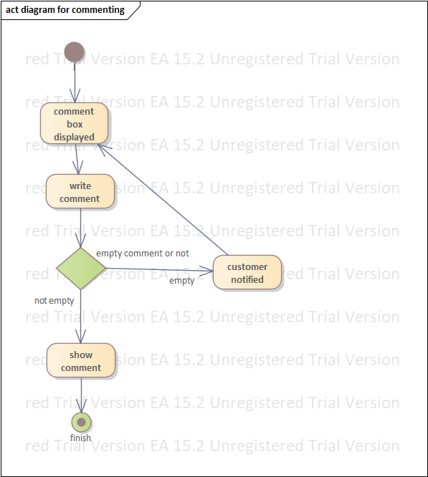

**Figure 16 activity diagram for commenting and complaining**

**3.6.3 State chart diagram**

**It is used to describe the externally visible behavior of a system or of an individual object. Some of the state chart diagrams of our system are described below.**

**1. Registering users**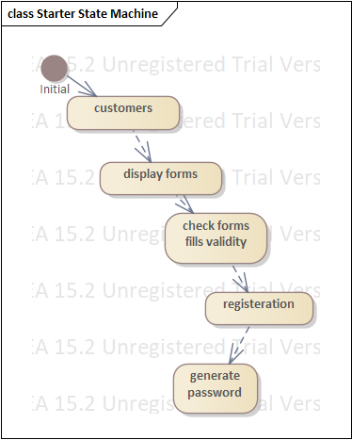

**Figure 17 state chart diagram for registering user**

**2.See and access product**

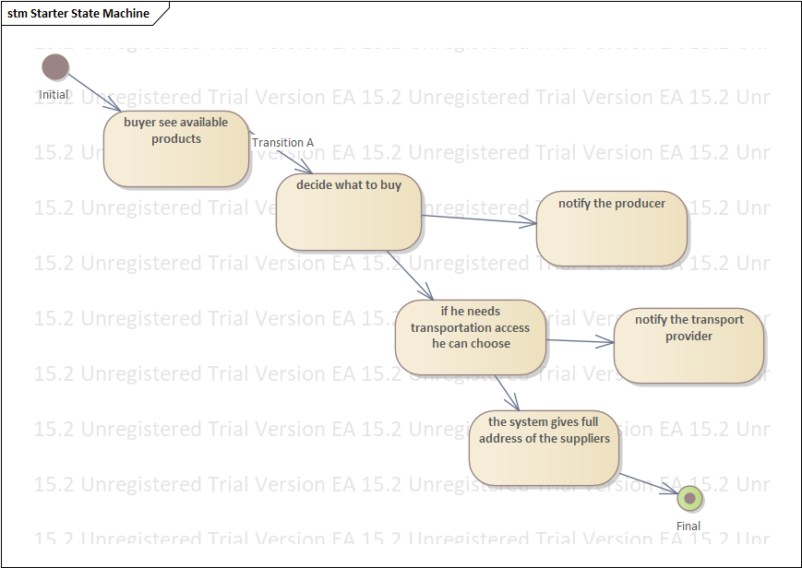

**Figure 18 state chart diagram for see and access product**

**3.Posting/ updating/ deleting product**

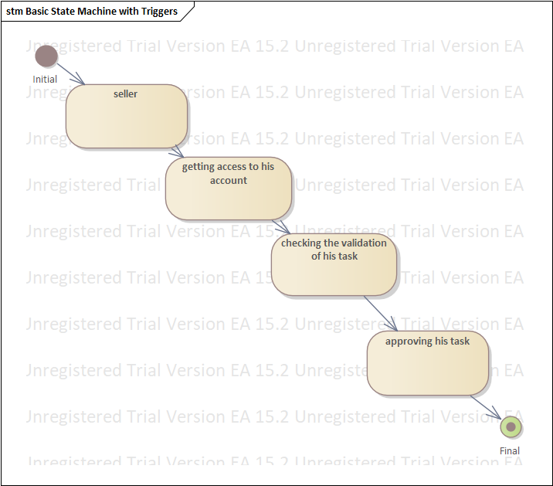

**Figure 19 state chart diagram for posting/updating/deleting product**

**4.posting/ uploading/ deleting transportation**

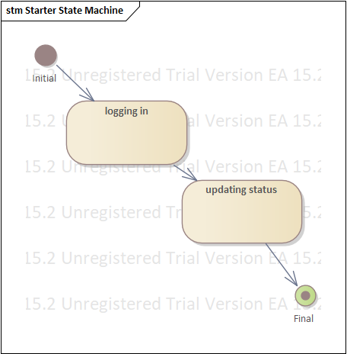

**Figure 20 state chart diagram for posting/updating/deleting transportation**

**5.Accessing system by mobile phone**

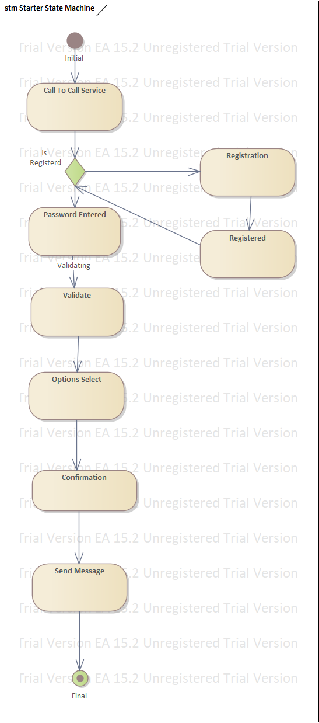

**Figure 21 state chart diagram for accessing system by using mobile phone**

**6.Registering branch admin**

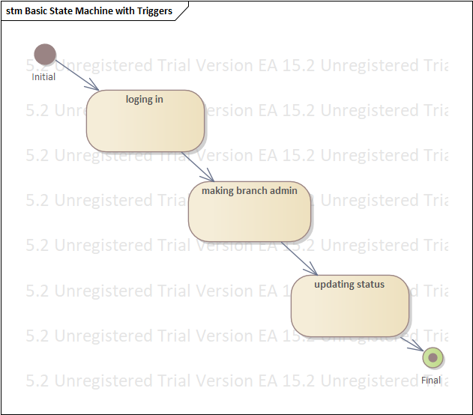

**Figure 22 state chart diagram for registering branch administrator**

**7.Commenting and complaining**

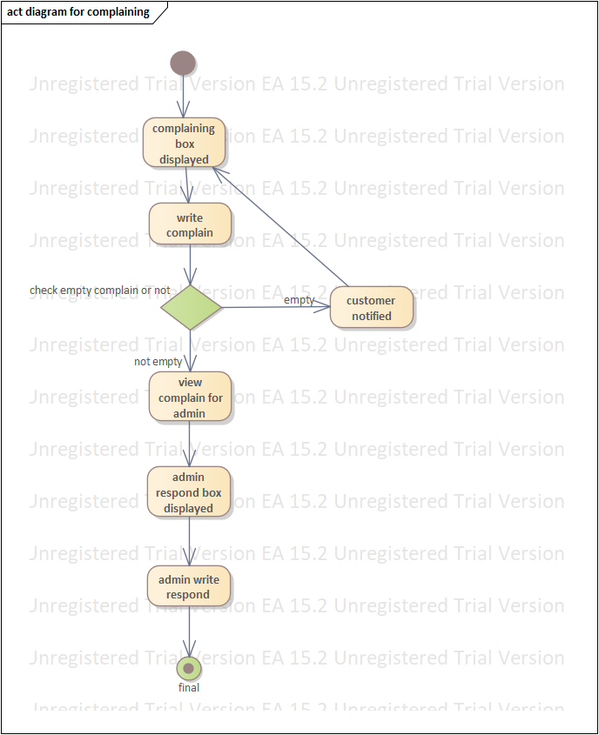

**Figure 23 state chart diagram for commenting and complaining**

**Chapter 4**

**4. System design**

**4.1. Overview of system design**

**System design part of the system is the transformation of the analysis model into a system design model. Up to now, we were in the problem domain. System design is the first part to get into the solution domain in a software development. This chapter focuses on transforming the analysis model into the design model that takes into account the non-functional requirements and constraints described in the problem statement and requirement analysis sections discussed earlier.**

**This document describes the design issues of the overall system, such as design goal, subsystem decomposition, hardware/software mapping, and persistent data management. It provides the complete architectural overview of the proposed system. It is intended to capture and express the significant architectural decisions, which have been made, on the system.**

**4.1.1. Purpose of the system design**

**The purpose of designing is to show the direction how the system is built and to obtain clear and enough information needed to drive the actual implementation of the system. It is based on understanding of the model the software built on. The objectives of design are to model the system with high quality. Implementing of high quality system depend on the nature of design created by the designer. If one wants to change to the system after it has been put in to operation depends on the quality of the system design. So if the system is design effetely, it will be easy to make changes to it.**

**Overview of the proposed system. It is intended to capture and express the significant architectural decisions, which have been made, on the system.**

**4.1.2 Design goal**

**The objectives of design are to model the system with high quality. The design goals are derived from nonfunctional requirements that means non-functional requirement is the description of the feature characteristics and attribute of the system as well as any constraints that may limit the boundary of the proposed solution.**

**Design goals describe the qualities of the system that the developers should consider.**

* **Performance**
* **Dependability**
* **Maintenance**
* **End user**

**Performance**

**The system should respond fast with high throughput, i.e. it should perform the task quickly possible as possible such as registering, loading page, viewing information, update status and etc.**

**The system performs its task within a user acceptable time and space. This includes the following:-**

* **Response time: - depending on the strength of available network the system should be response in short period of time.**
* **Storage space: - to do work efficiently the processor to be more than 2GB RAM and HD storage to be more than 20MB**

**Dependability**

**Our system includes the following dependability criteria’s:-**

* **Reliability: -DRMIS system should be reliable.**
* **Fault Tolerance: - DRMIS should be fault tolerant to loss of connectivity with the service.**
* **Security: - DRMIS should be secured, i.e., not allow other users or unauthorized users to access data that has no the right to access it.**
* **Availability: - as long as there is an internet connection and system failure the system will be available 24 hours a day.**
* **Robustness- it should have ability to survive invalid user**
* **Safety- ability to not endangered human lives, even in the presence of errors and failures**

**Maintainability**

**To be maintainable the system should meet the following maintenance criteria:-**

* **Modifiability:- : DRMIS system should be modifiable for further modification and enhancement of the system**
* **Portability: -the system is developed to be viewed and retrieved from any web browser regardless of their version and platform it resides in it.**
* **Extensibility: - if it is needed to add new functionality to the system, this must be achieved by only making a separate page and integrate this page with the existing system.**
* **Readability: - the system code can be viewed by clicking on the current web page and choose “view the source code” option.**
* **Traceability of requirements- it should be easy to map the code to the specific requirements**

**End User Criteria**

**The system should have simple and understandable graphical user interface such as forms and buttons, which have descriptive names. It should give reliable response for each user comment. All the interfaces, forms and buttons are written or designed in a simple language or common language so that the user can access it without any difficult.**

**4.2. Proposed system architecture**

**In this project, the team uses a three-tier architecture, which has three layers. These three layers are the Application or Presentation layer, the business layer and the data access layer. Application or presentation layer is the form, which provides the user interface to either programmer or end user. The business layer is the class, which the team uses to write the function, which works as a mediator to transfer data from application layer or presentation layer to data layer. This layer also has a property layer which is a class where variables are declared corresponding to the fields of the database which can be required for the application and make the properties so that the team can get or set the data using these properties into the variables. The third tire is the data access layer which is also a class to get or set data to the database queries back and forth. This layer only interacts with the database. The database queries or stored procedures will be written here to access the data from the database or to perform any operation to the database**

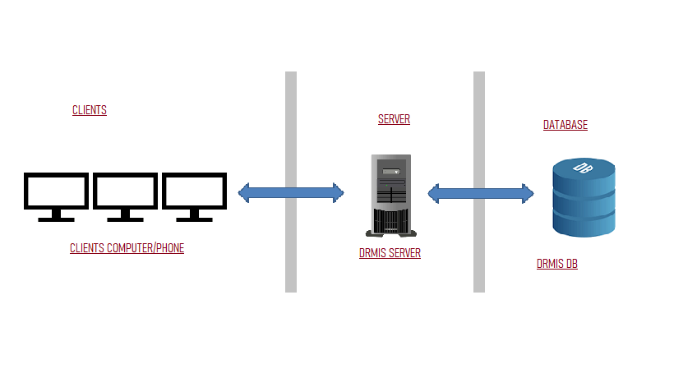

**Figure 24 system architecture**

**4.2.1. System process**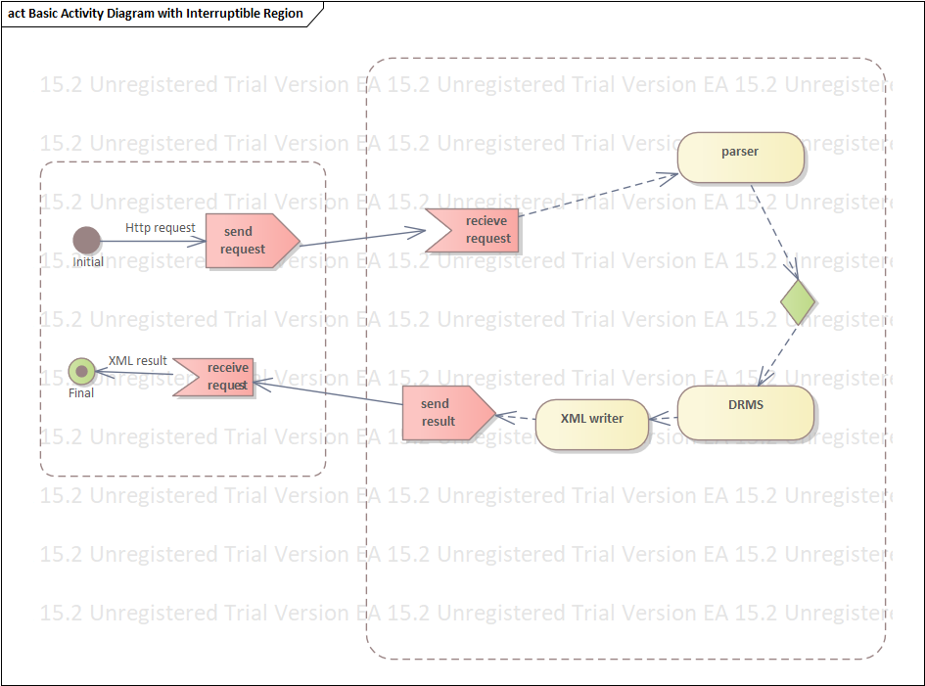

**Figure 25 system activity design**

**Over all system of the service depicted below.**



**Figure 26 overall DRMS**

**DRMIS System process**

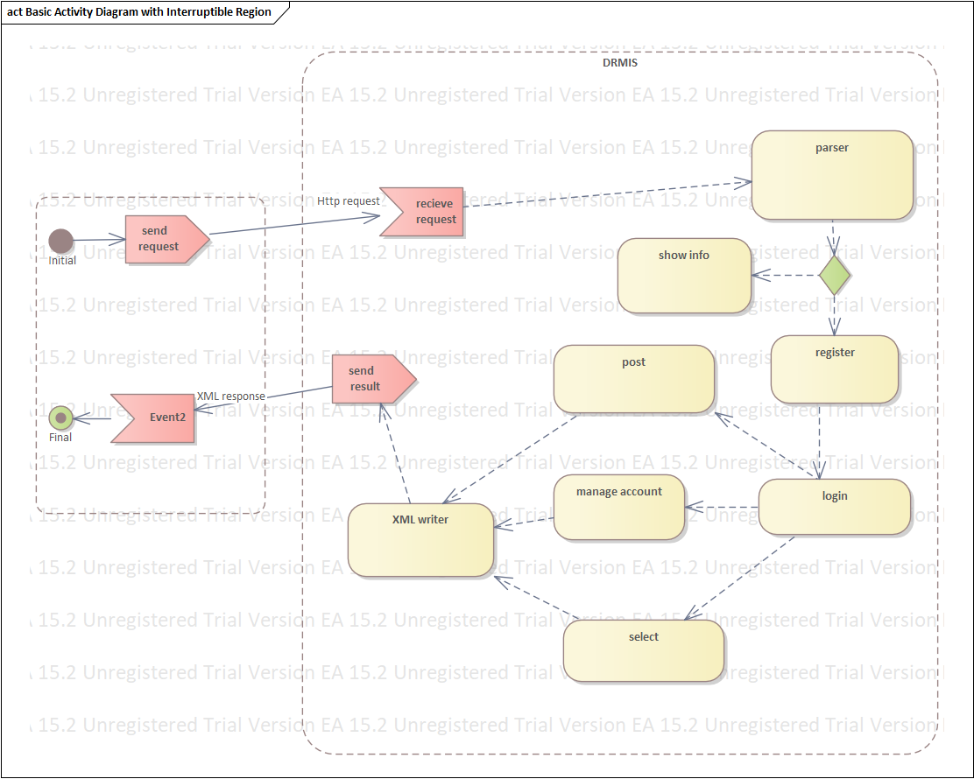 **Figure 27 system process**

**4.2.2. Subsystem decomposition**

**To reduce the complexity of the solution domain, we decompose a system into simpler parts, called subsystems. The main need of this portion is to design the external part of the system. In this project, there are seven sub system decompositions.**

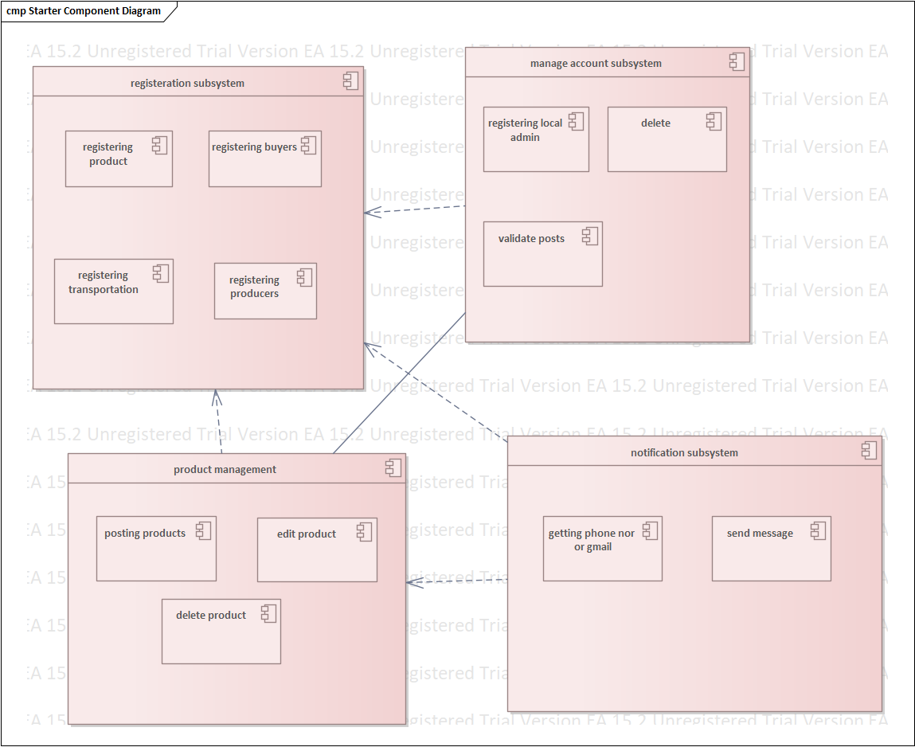 **Figure 28 subsystem decomposition**

**Subsystem decomposition description**

|  |  |  |
| --- | --- | --- |
| **Subsystem** | **Purpose** | **Class** |
| **Registrations** | **to register all registration and to manage it** | **Product, producer, buyer, transportation.** |
| **Manage accounts** | **Responsible for managing registered product, transportation, producer, buyer and responsible for tasks that accomplished through the system** | **Assign role or permission** |
| **Product management** | **The purpose of this managing the product issue, means posting, deleting, editing.etc** |  |
| **Notification** | **The purpose of this is notifying producers, buyers, transporters information related to them** |  |

**Table 7 subsystem description**

**4.2.3. Hardware/ software mapping**

**When we say hardware/software mapping for the system, it describes how subsystems are assigned to hardware and off-the-shelf components. It also lists the issues introduced by multiple nodes and software reuse. In this system design mainly there are three hardware components. The client side, server side and database side. When the team applies the system, necessary software will be loaded to each side hardware components. Network should be installed between each side. Then each sub system software will be assigned and configured to the mapped hardware. Then the local area network will be connected to the internet and the system will be functional. But now it is a design phase. The hardware software mapping of the system is described below with a simple diagram.**

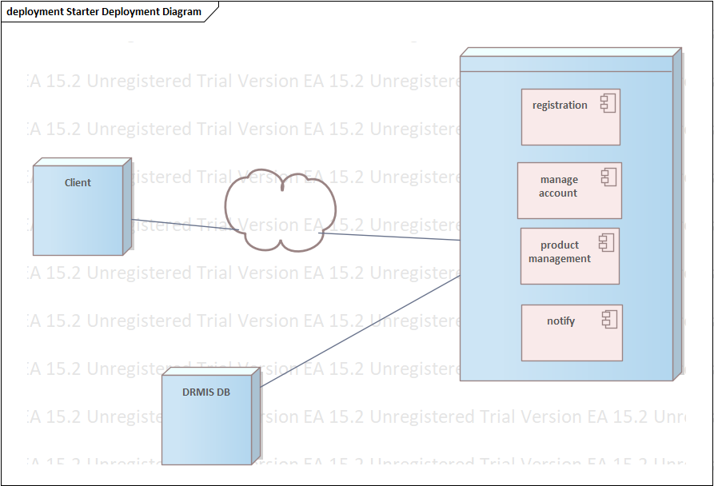 **Figure 29 hardware/software mapping**

**4.2.4. Persistent data management**

**The purpose of this section is to show the mapping of the objects/classes of the system, identified during the analysis stage, in to the corresponding relational database**

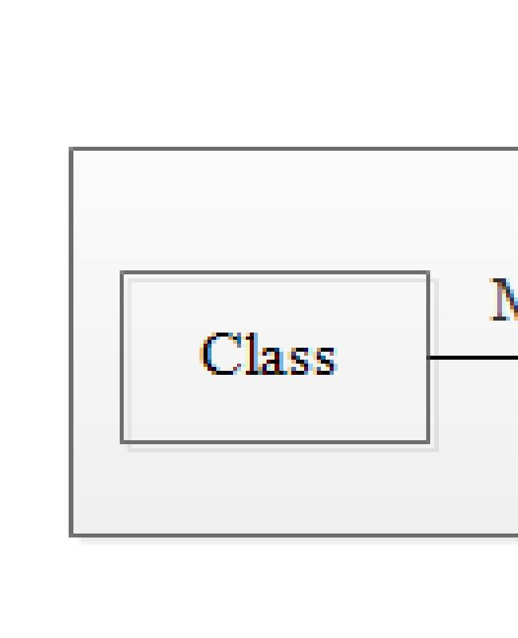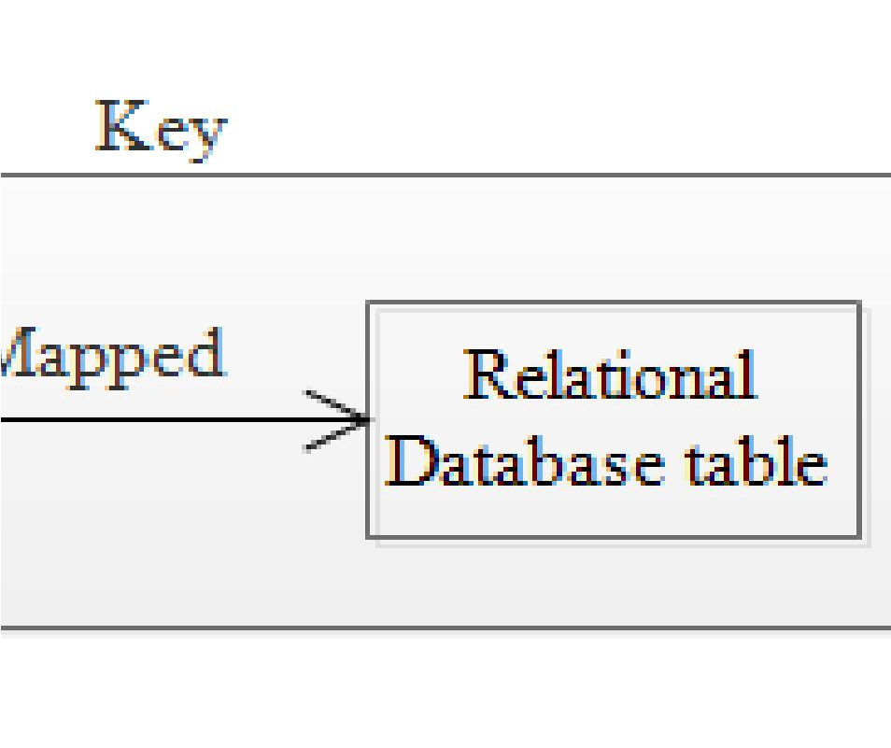

**Figure 30 class to relational database mapping**

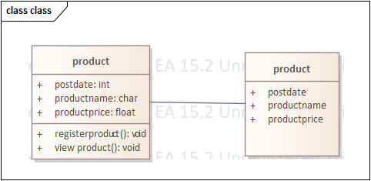

**Figure 31 product mapping**

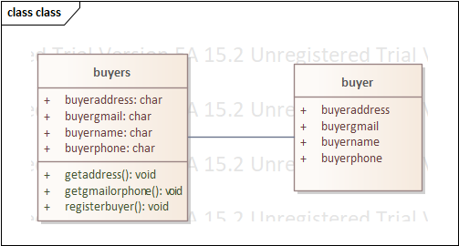

**Figure 32 consumer mapping**

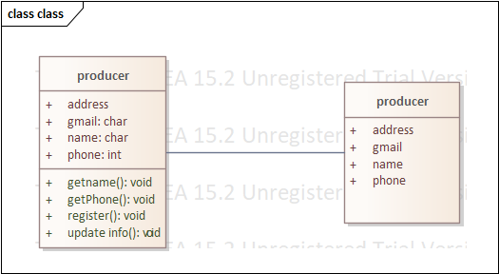

**Figure 33 producer mapping**

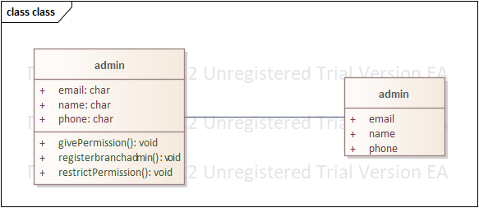

**Figure 34 administrator mapping**

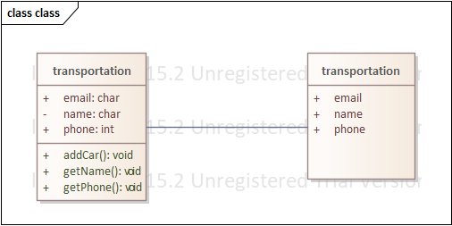

**Figure 35 transportation mapping**

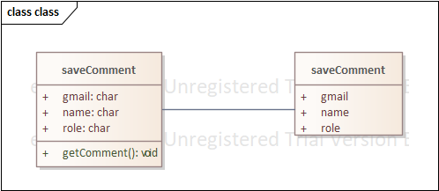

**Figure 36 save comment mapping**

**4.2.5. Component diagram**

**The following component diagram represents a group of graph of components connected by dependency relationships and dependencies are shown as dashed arrows from the client component to the supplier component.**

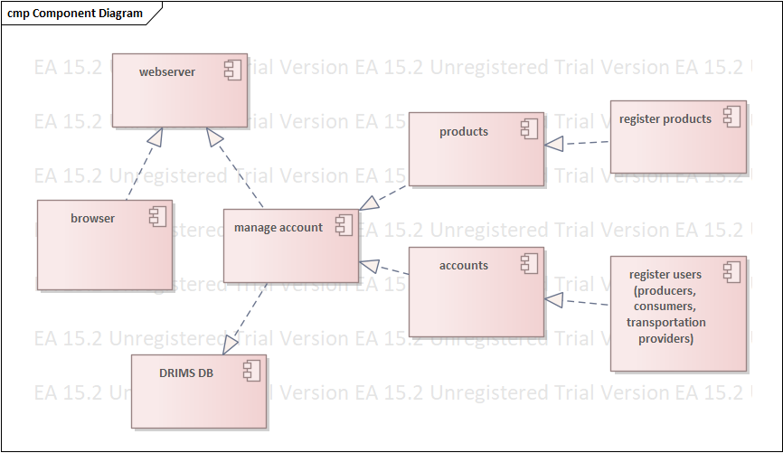

**Figure 37 component diagram**

**4.2.6. Deployment diagram**

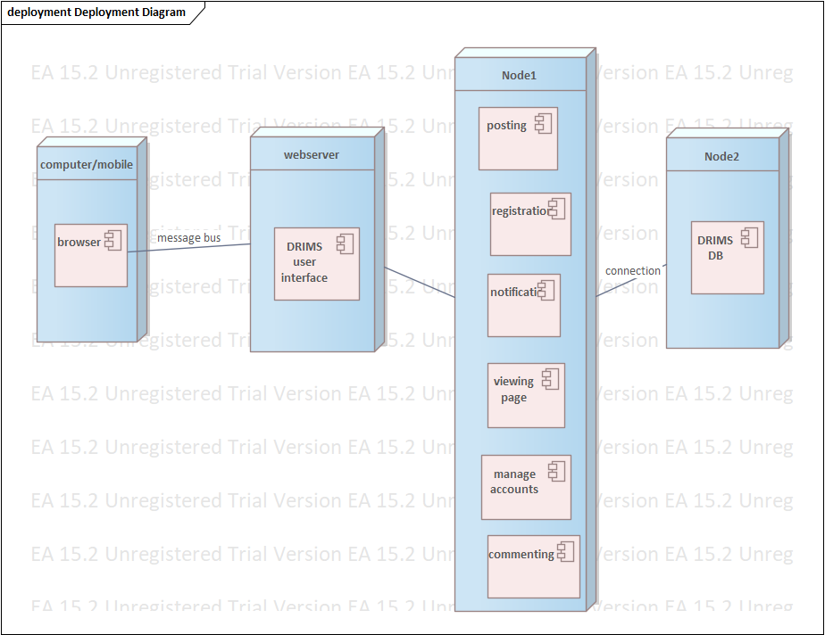

**Figure 38 deployment diagram**

**4.2.7. Database design**

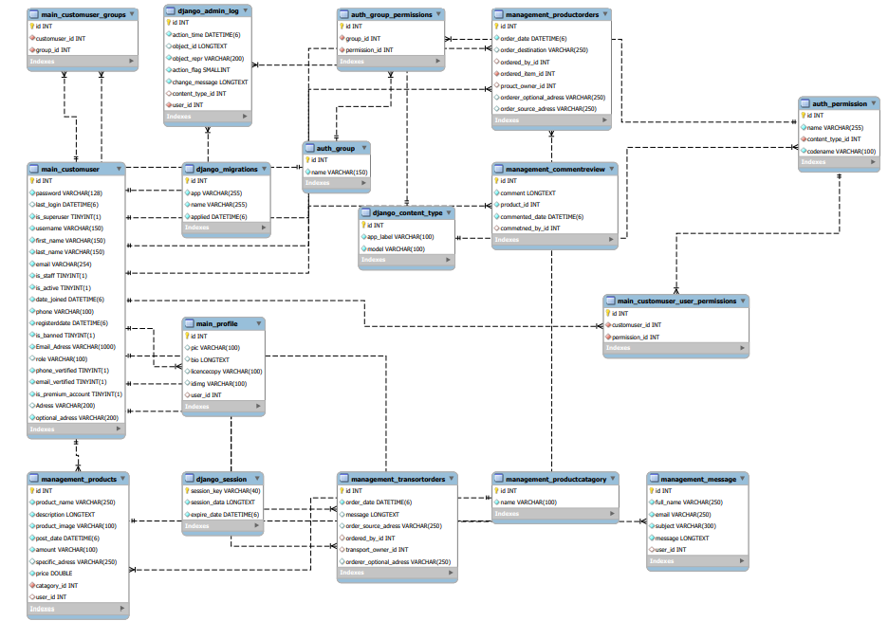

**Figure 39 database design**

**4.2.8. Access control**

**In multiuser systems, different actors have access to different functionality and data. We modeled these distinctions by associating different use cases to different actors. This is described by the following access matrix.**

|  |  |  |  |  |
| --- | --- | --- | --- | --- |
| **Object actors** | **Register** | **Account** | **Comment** | **Notification** |
| **Admin** |  | **create_account()**  **view_account()**  **delete_account()**  **update_account()** | **view_comment()**  **give_comment()** | **send_notification()**  **get_notification()** |
| **Branch admin** | **register_b.admin()** | **view_account()**  **update_status()** | **view_comment()**  **give_comment()** | **get_notification()** |
| **Producer** | **register_producer()** | **view_account()**  **update_status()** | **view_comment()**  **give_comment()** | **get_notification()** |
| **Consumer** | **register_consumer()** | **view_account()**  **update_status()** | **view_comment()**  **give_comment()** | **get_notification()** |
| **Transport provider** | **register_transportprovider()** | **view_account()**  **update_status()** | **view_comment()**  **give_comment()** | **get_notification()** |
| **Viewer** |  |  | **view_comment()**  **give_comment()** |  |

**Table 8 access control**

**4.2.8. User interface design**

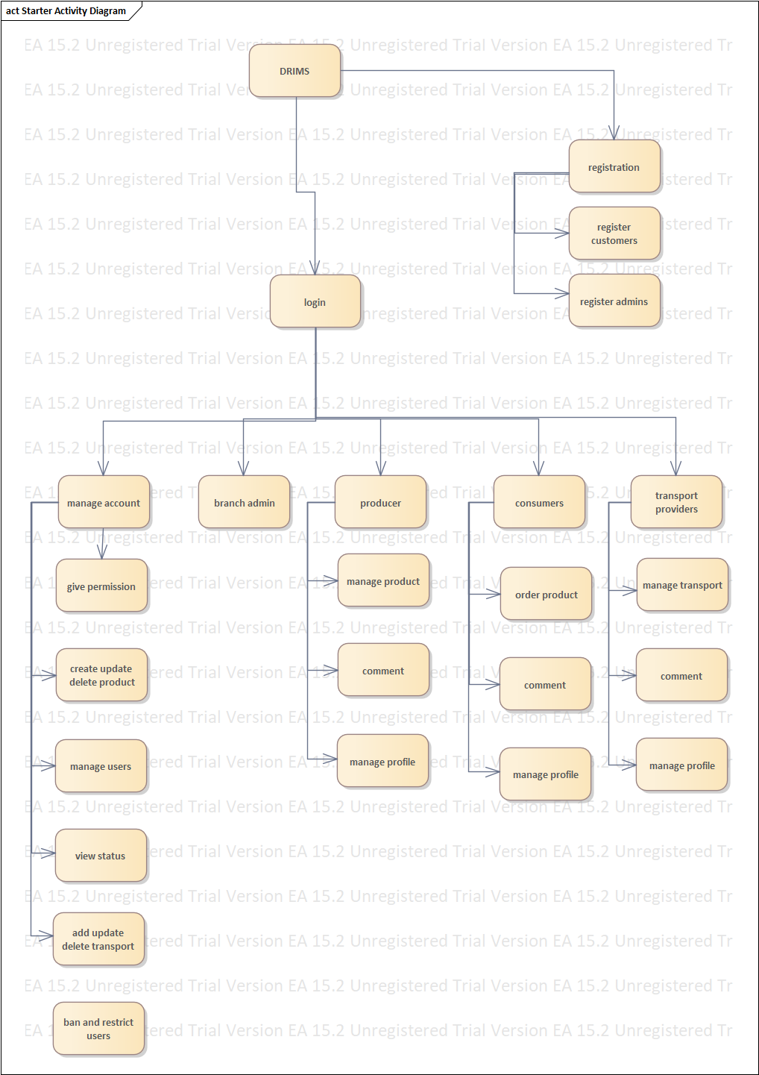

**Figure 40 user interface**

**Reference**

1. **Teklebirhan Ambaye Construction Project Management System documentation**
2. **Lecture ppts of fundamentals of software engeenering**